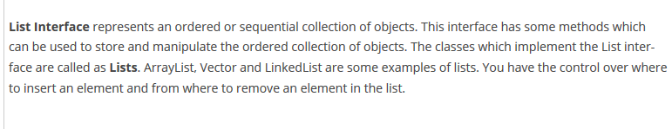

Here sequential means, elements are added or appended at the end of the list.

For instance, list.add(4) - will add the element at the end of the list.

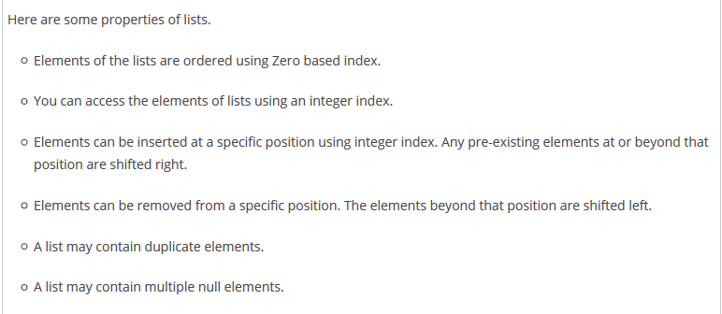

**Difference between Array and Array list**

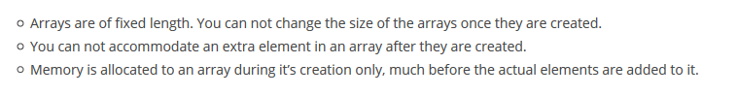



**But cannot traverse in array.**